# Oracle Install for 11g Database for GIS Development Machine

1) Copy win32 1 & 2 zips from \\sfetgis-nas01\sfgispoc_data\ApplicationDevelopment\IBM_TeamMembers\RobRader

2) Unzip / Merge

3) setup.exe

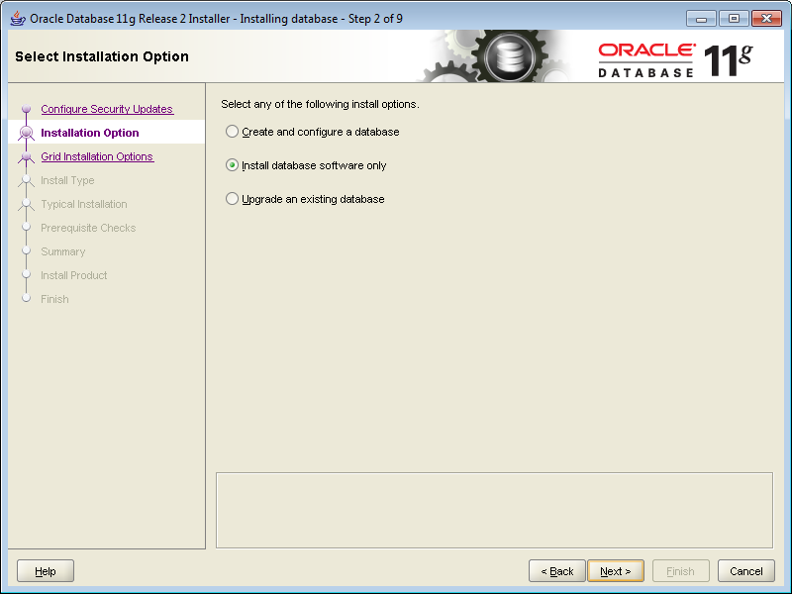

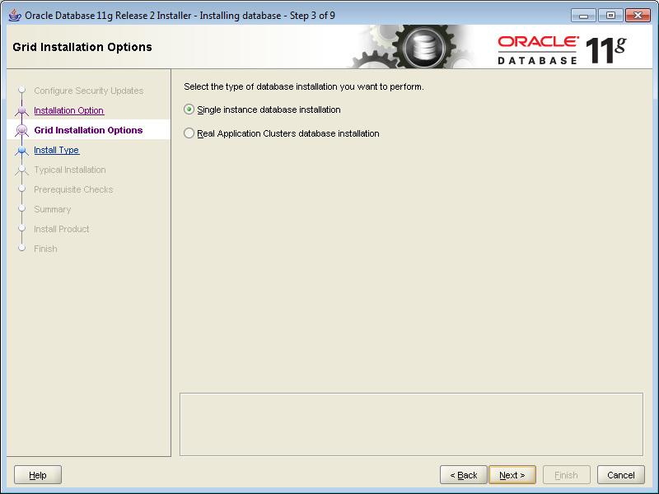

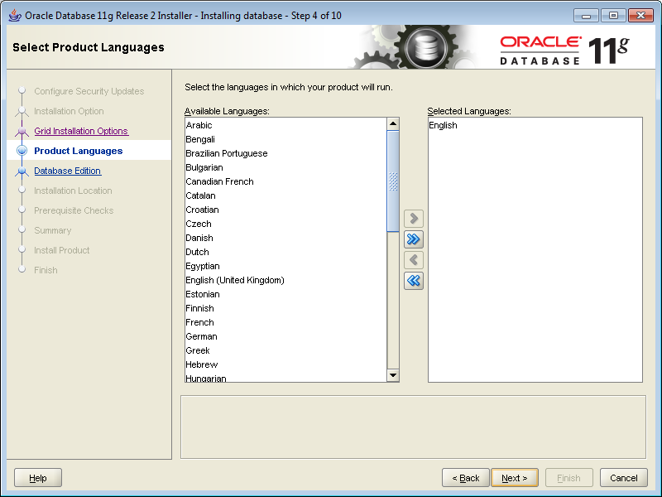

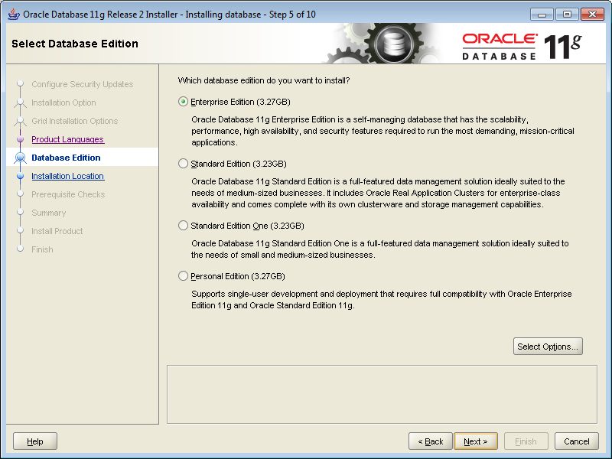

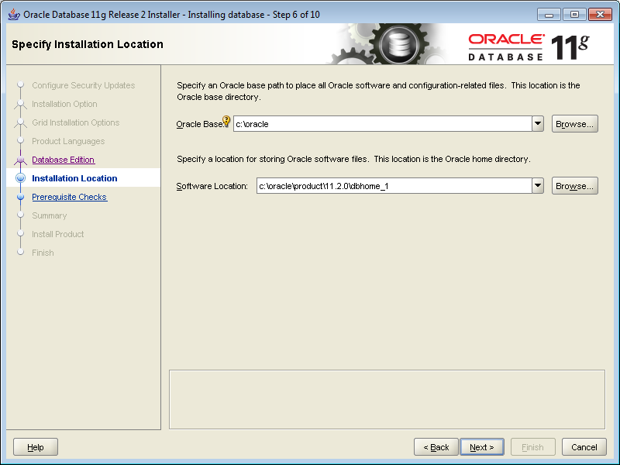

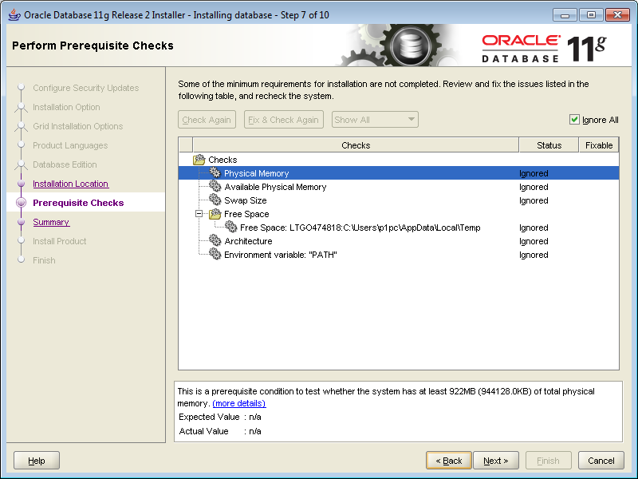

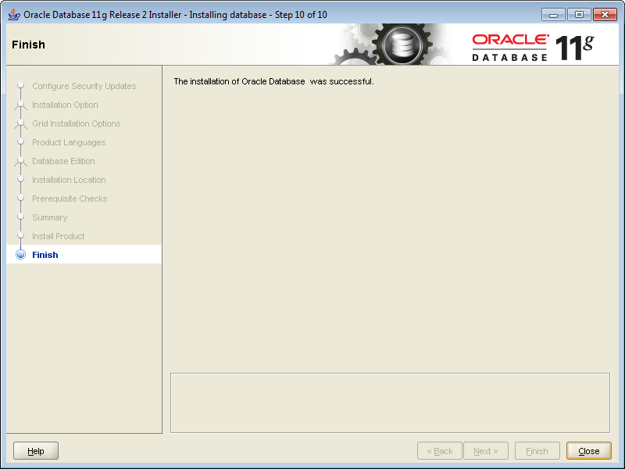

DCA: Be sure to run Database Configuration Assistant as Administrator (Rt Click on it -> Run as admin…)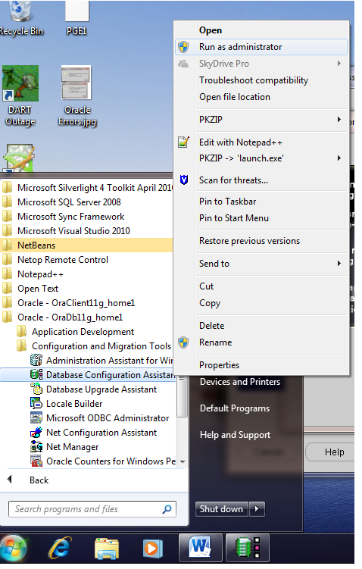

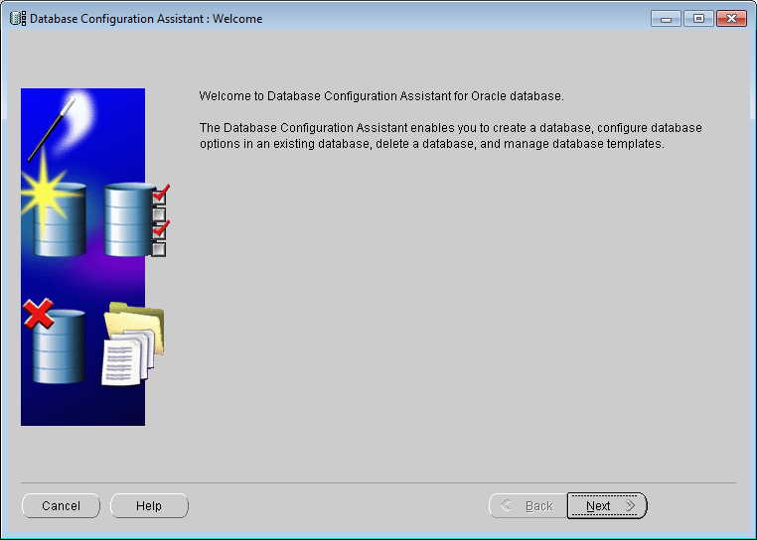

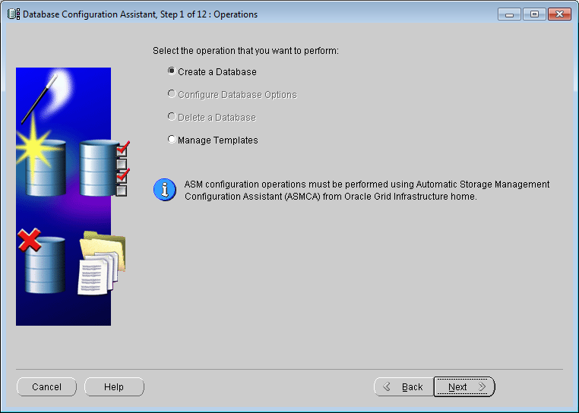

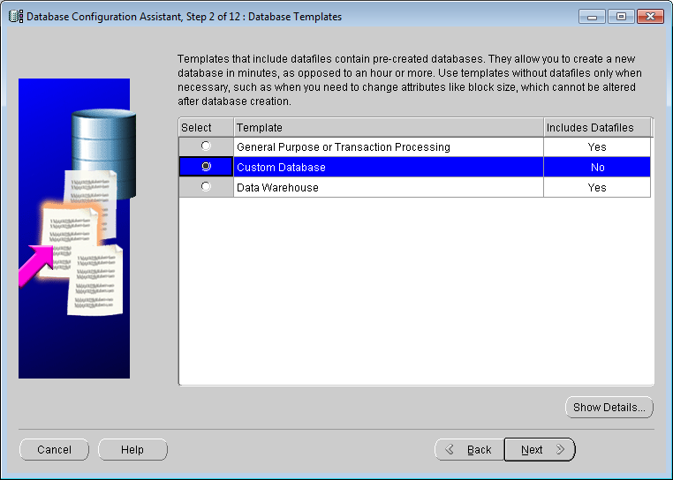

COPY template from "\\sfetgis-nas01\sfgispoc_data\ApplicationDevelopment\IBM_TeamMembers\PhilPenn\PGE1.dbt"

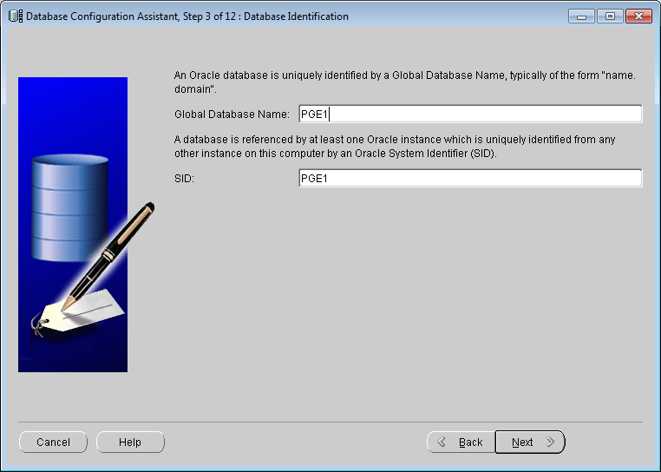

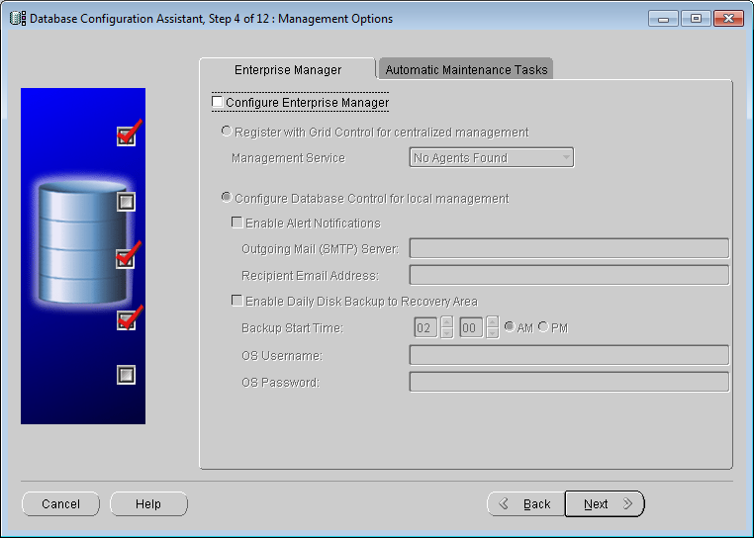

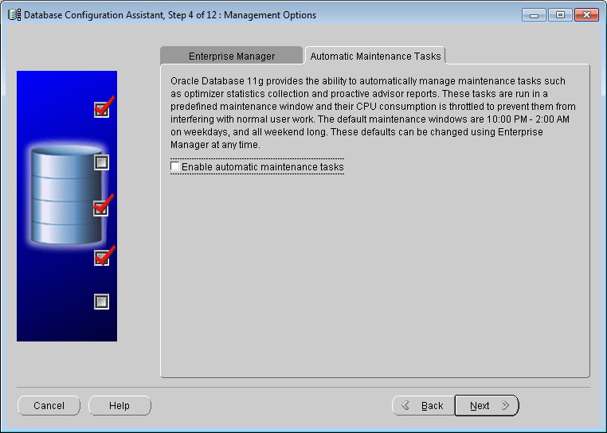

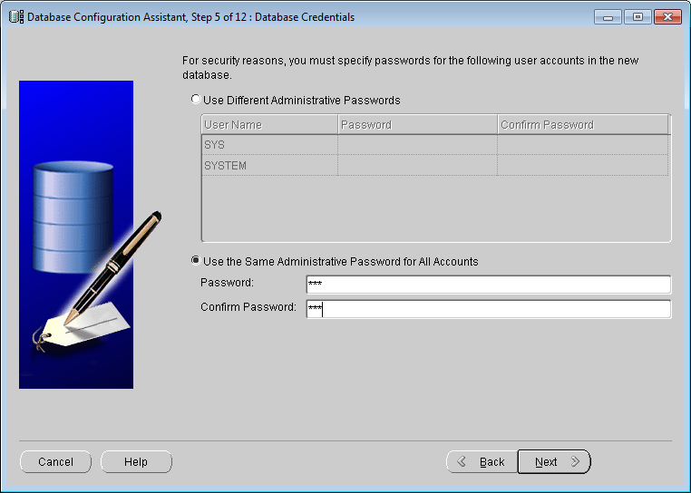

sys

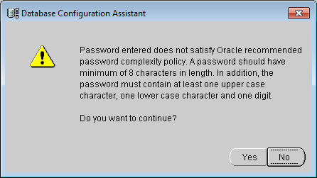

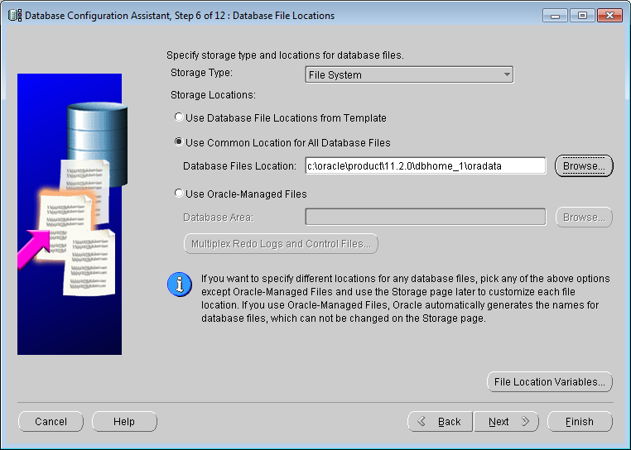

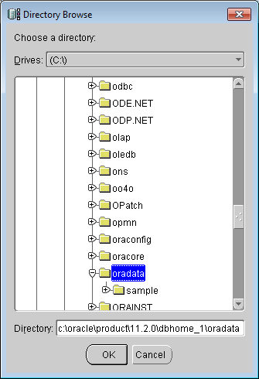

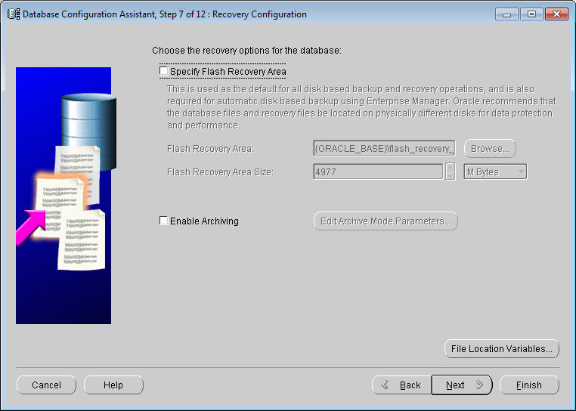

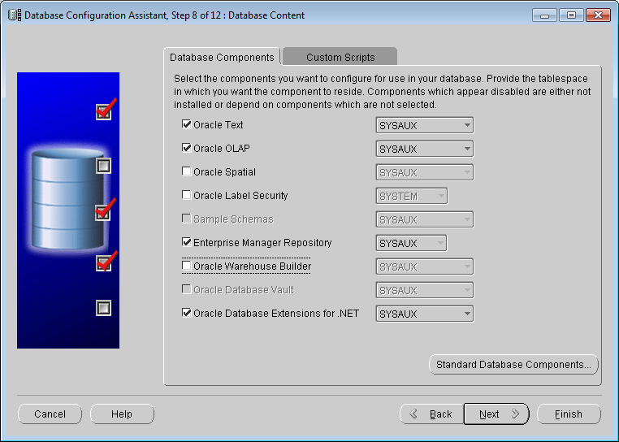

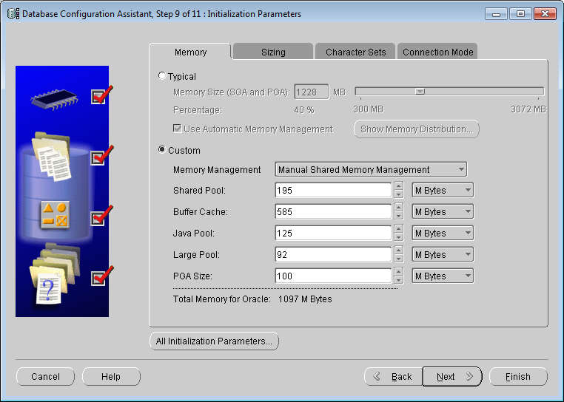

**Afterwards buffer cache -> 300, javapool ->25**

**Create spfile from pfile;**

**Find spfile under oradata, edit to change the buffer/java above then**

**Sqlplus sys/sys@pge1 as sysdba**

**Shutdown immediate**

**Startup spfile=<spfile>**

**Create pfile from spfile**

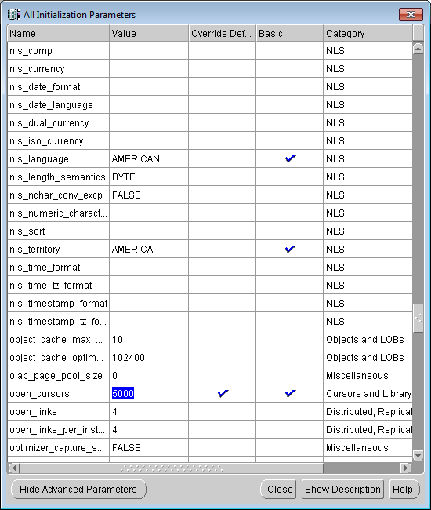

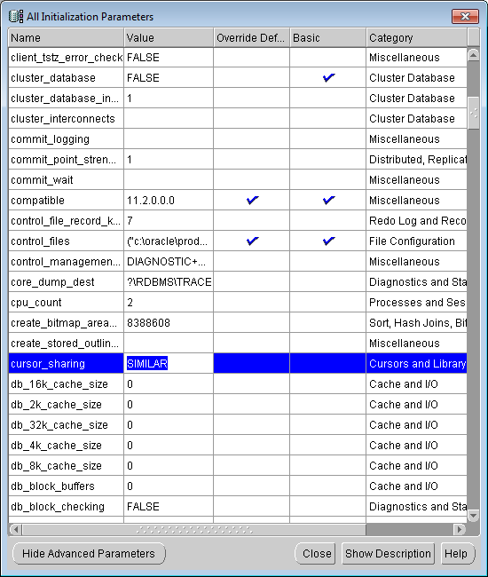

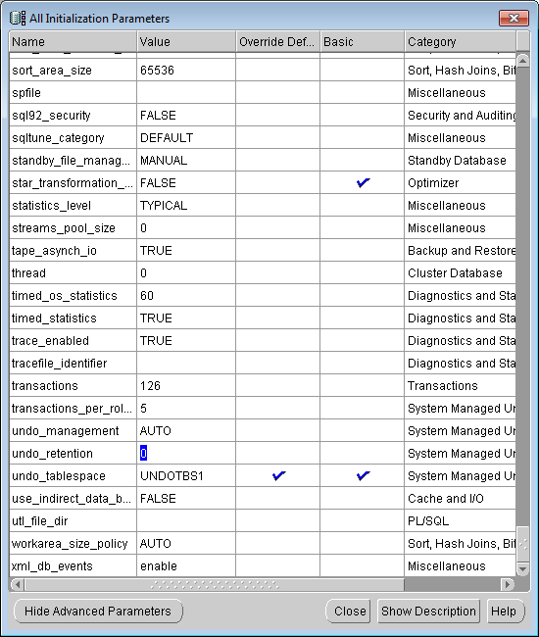

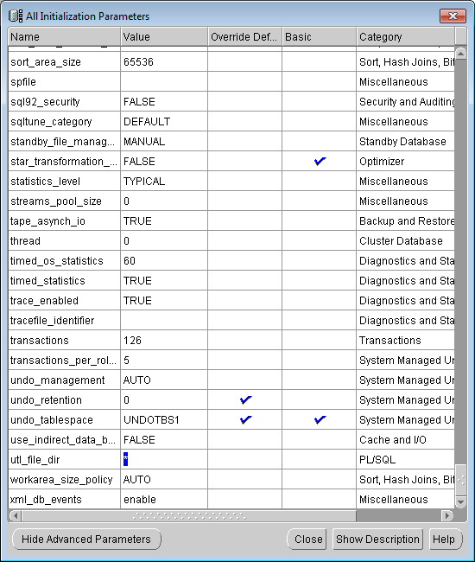

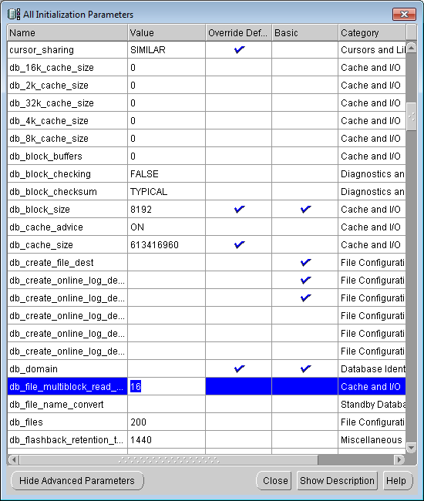

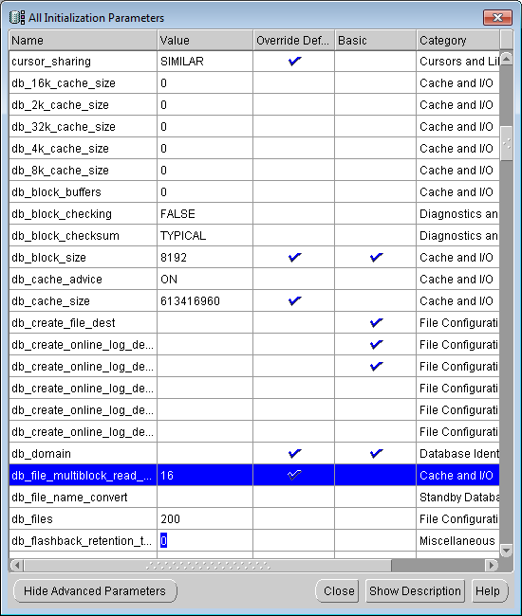

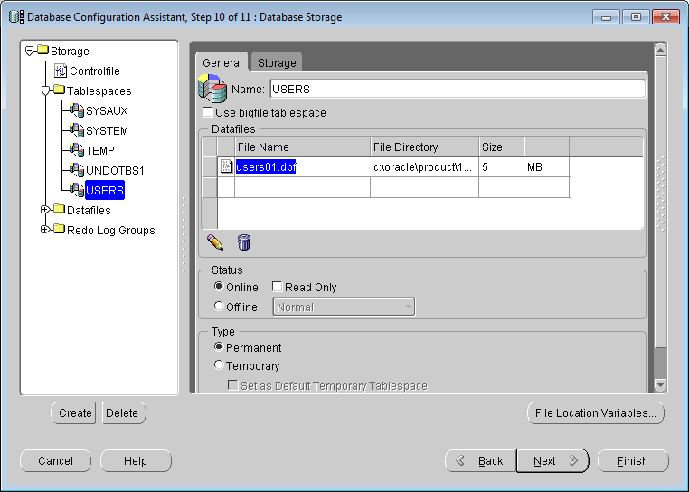

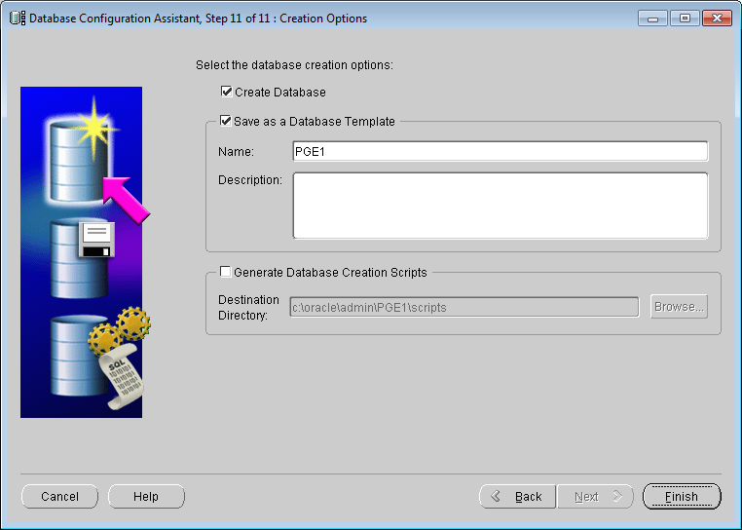

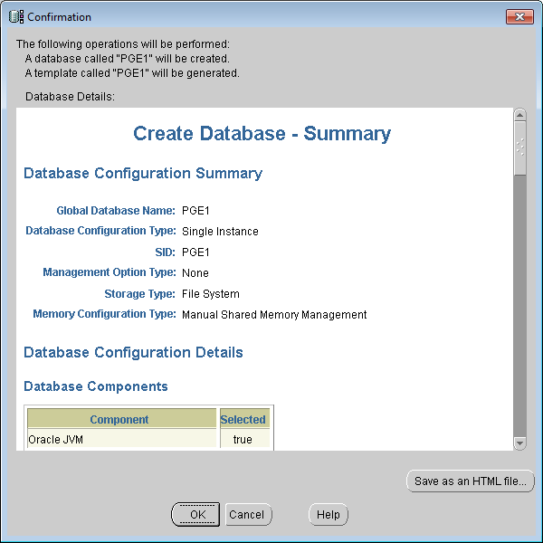

**Configure TNS Listener**

**Run Net Configuration Assistant**

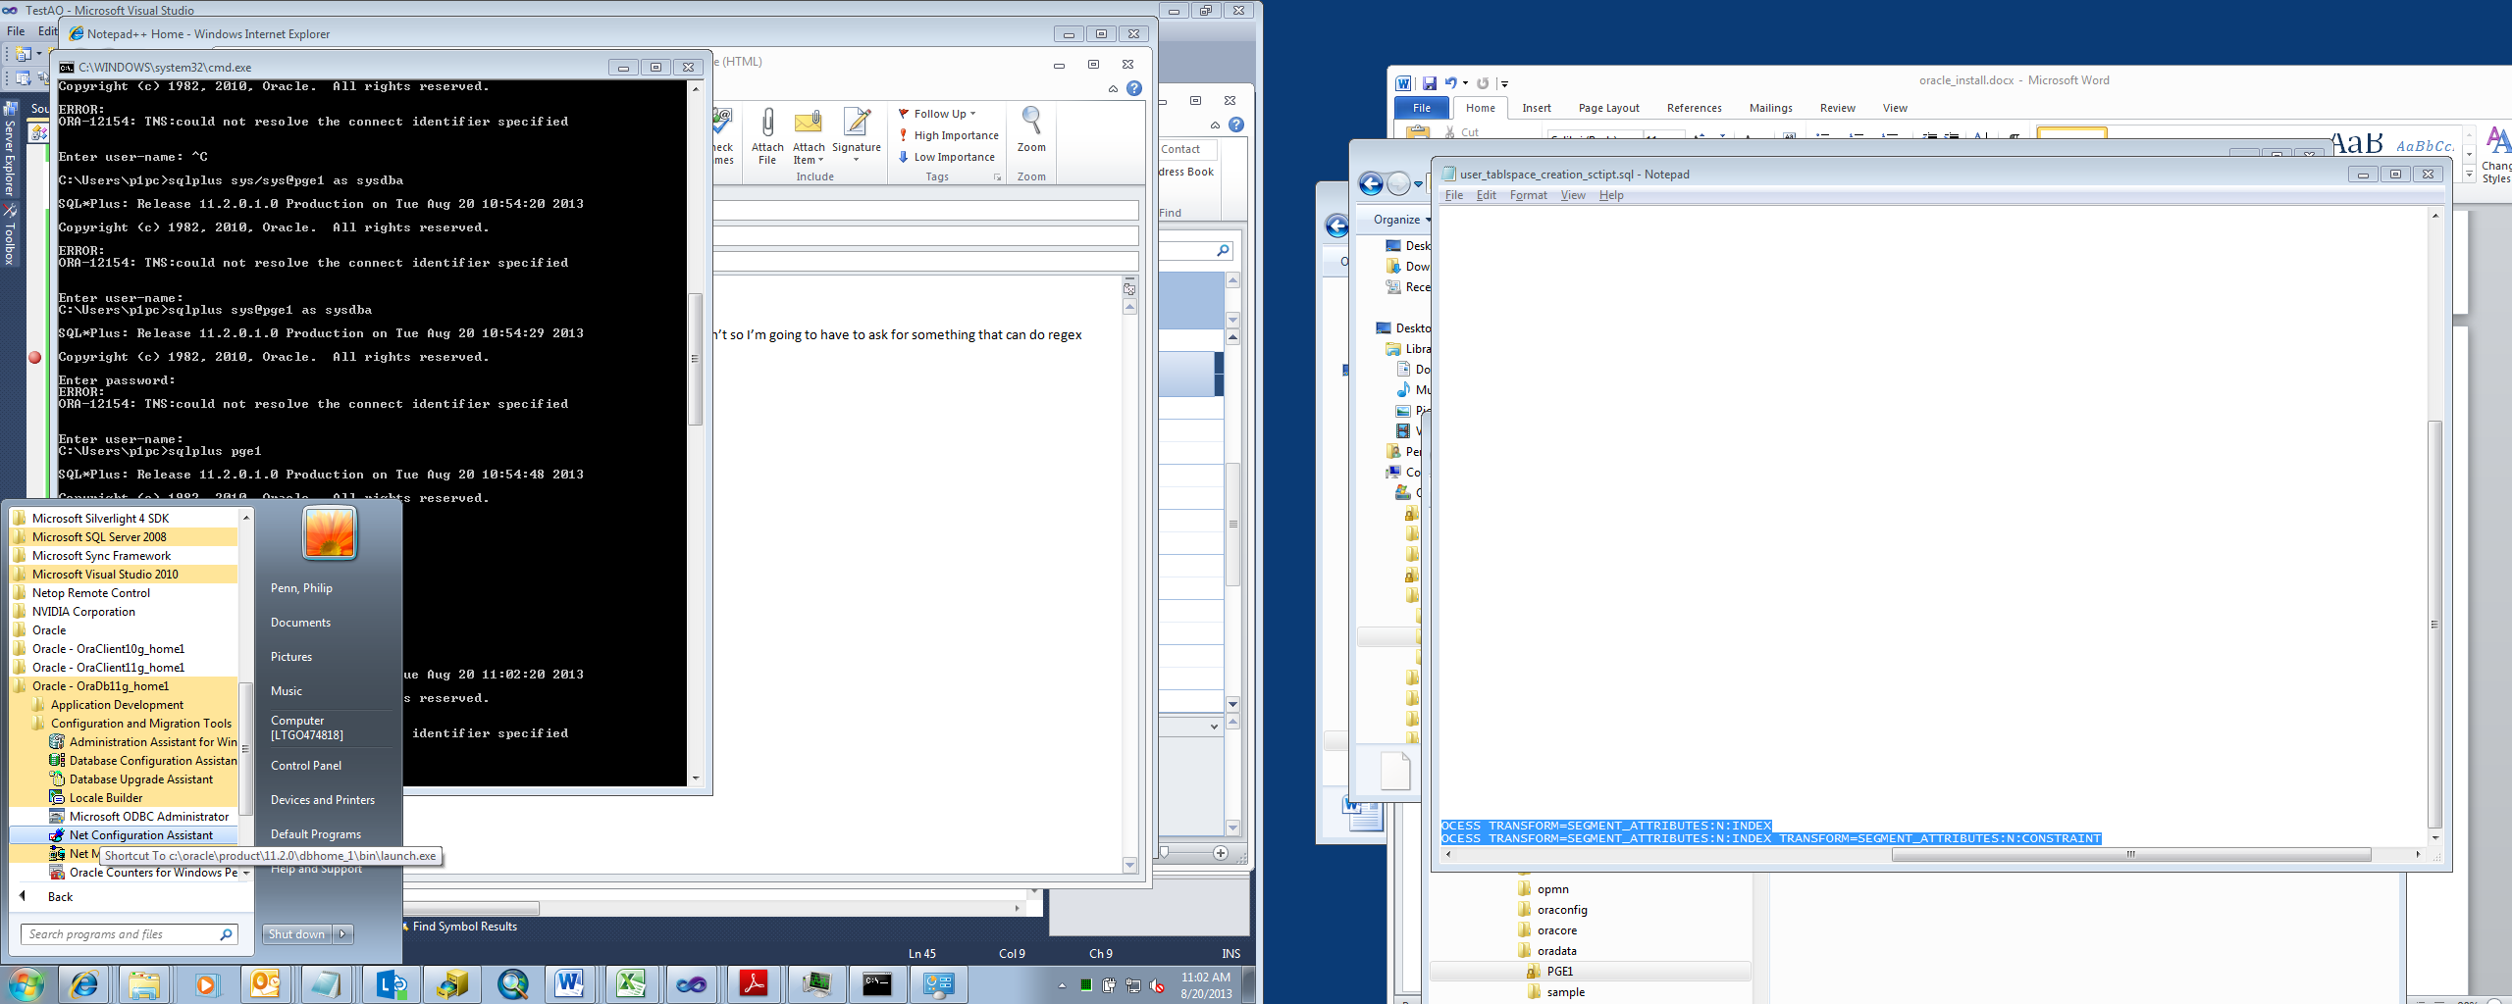

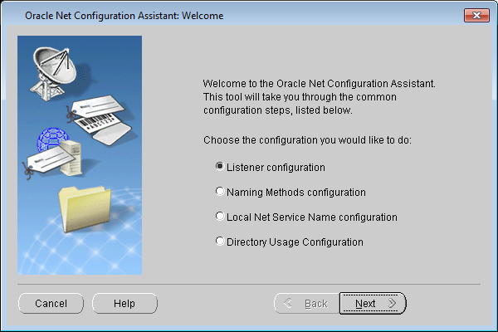

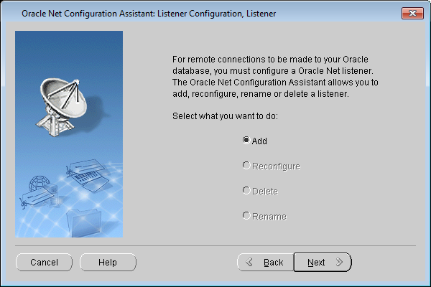

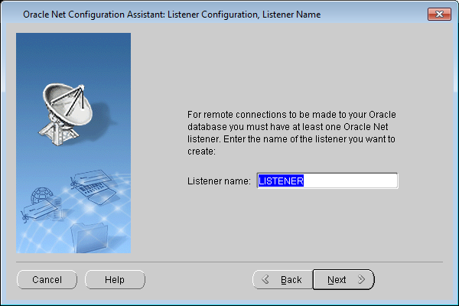

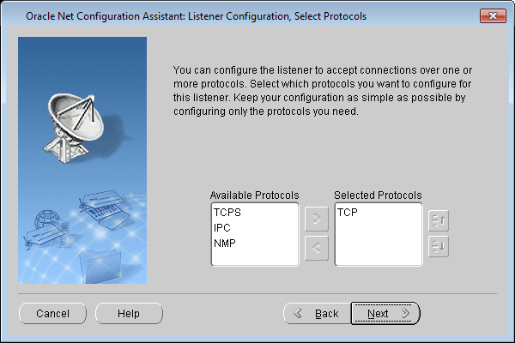

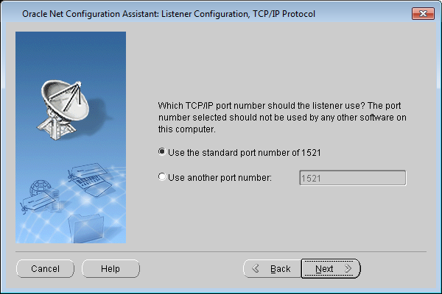

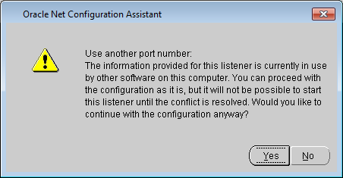

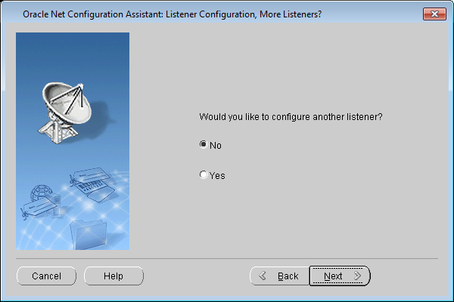

**Finish**

**Remove TNS_ADMIN environment var**

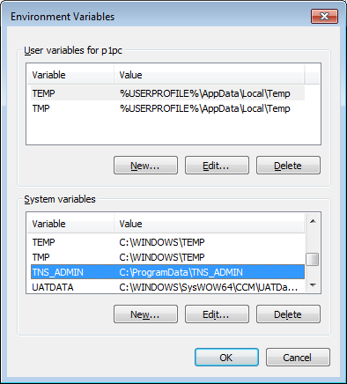

**Lsnrctl start (may fail)**

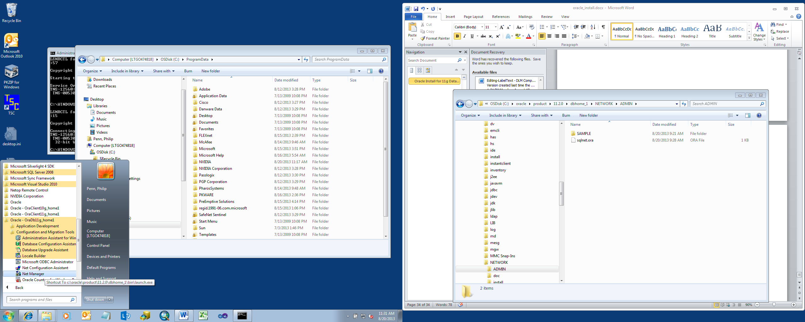

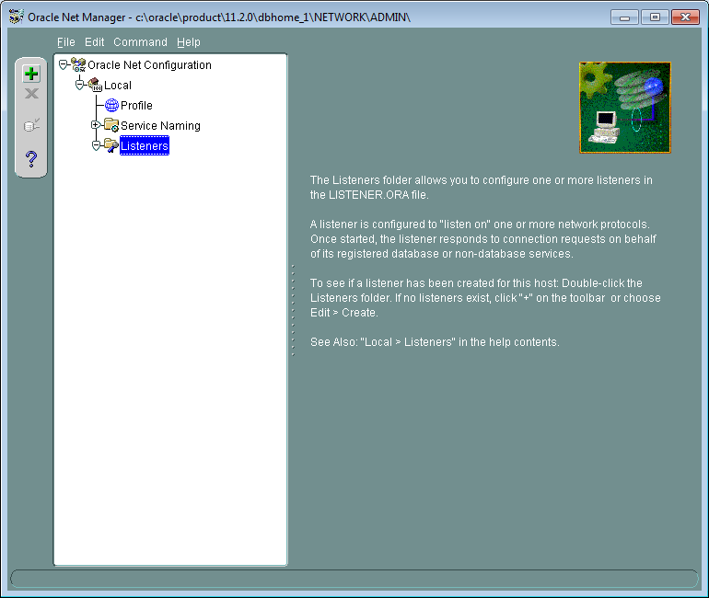

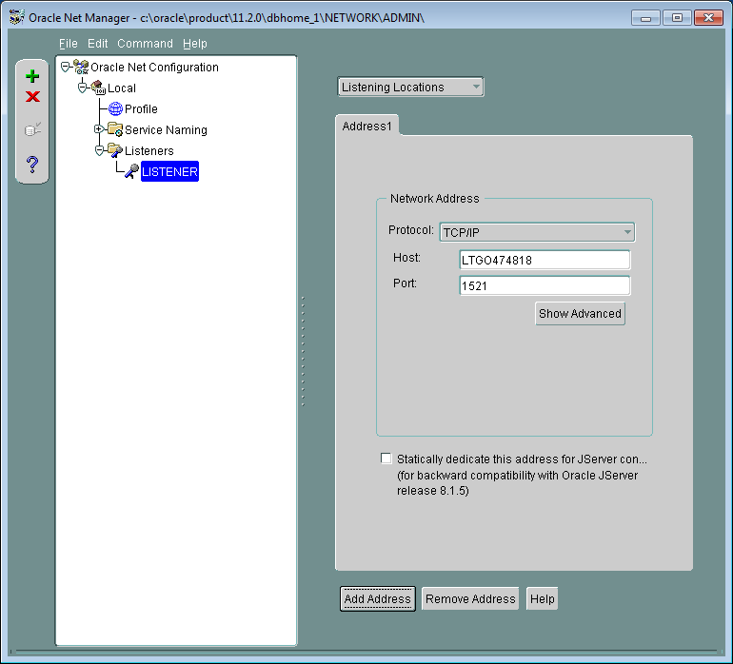

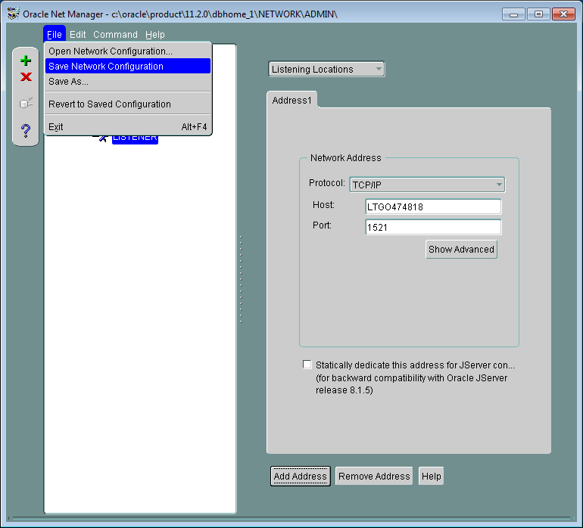

**Grant everyone full control to C:\oracle\product\11.2.0\dbhome_1\NETWORK**

**Copy TNSNAMES.ORA, SQLNET.ORA**

**Modify tnsnames.ora e.g.**

**PGE1 , PGE1.WORLD =**

**(DESCRIPTION =**

**(ADDRESS_LIST =**

**(ADDRESS = (PROTOCOL = TCP)(HOST = LTGO474818)(PORT = 1521))**

**)**

**(CONNECT_DATA =**

**(SERVICE_NAME = PGE1)**

**)**

**)**

**Rename Production so that you don’t inadvertently connect when running Swizzle (Data Sources Wizard)**

**EDGISP1**P **, EDGISP1**P**.WORLD =**

**(DESCRIPTION =**

**(ADDRESS_LIST =**

**(ADDRESS = (PROTOCOL = TCP)(HOST = edgisdboraprd01.comp.pge.com)(PORT = 1521))**

**)**

**(CONNECT_DATA =**

**(SERVICE_NAME = EDGISP1P)**

**)**

**)**

**Change Hosts file add the following, where LTGO474818 is machine name.**

**127.0.0.1 localhost LTGO474818**

**Edit the tablespace script ("\\sfetgis-nas01\sfgispoc_data\ApplicationDevelopment\IBM_TeamMembers\PhilPenn\user_tablspace_creation_sctipt.sql"), replace p1pc with your user:**

**Run the Tablespace Creation script**

**Copy DMP/LOG from TFS location (grabbed by search for backup edgis1p) to oradata**

**In sqlplus**

**create directory dumps as 'C:\oracle\product\11.2.0\dbhome_1\oradata';**

**grant all on directory dumps to system;**

**alter user sde identified by sde ;**

**alter user edgis identified by edgis ;**

**alter user process identified by process ;**

**alter user system identified by sys ;**

## Restore from a backup

Estimate: 1.5 hours to complete

Copy .dmp locally to C:\oracle\product\11.2.0\dbhome_1\oradata\ from \\sfetgis-nas01\sfgispoc_data\Backups

Backup local files in "C:\oracle\product\11.2.0\dbhome_1\oradata\PGE1" to "C:\oracle\product\11.2.0\dbhome_1\oradata\PGE1_Copy"

Stop Database/TNS Listener Services

Remove PGE1 folder

Copy PGE1_Blank to PGE1

Start Database/TNS Listener Services

impdp system/sys dumpfile=edgis1p.dmp directory=dumps logfile=import_try1.txt schemas=SDE,EDGIS,PROCESS,DMSSTAGING TRANSFORM=SEGMENT_ATTRIBUTES:N:INDEX TRANSFORM=SEGMENT_ATTRIBUTES:N:CONSTRAINT

grant execute on dbms_pipe to public;

grant execute on dbms_lock to public;

**alter user sde identified by sde ;**

**alter user edgis identified by edgis ;**

**alter user process identified by process ;**

**alter user system identified by sys ;**

**alter user p1pc identified by p1pc ;**

**create user p1pc identified by p1pc default tablespace EDGIS temporary tablespace temp;**

**grant connect to p1pc;**

**grant resource to p1pc;**

**grant create session to p1pc;**

**grant create table to p1pc;**

**grant create procedure to p1pc;**

**grant create sequence to p1pc;**

**grant create trigger to p1pc;**

**grant unlimited tablespace to p1pc;**

**grant sde_editor to p1pc;**

**grant mm_admin to p1pc;**

**grant mm_user to p1pc;**

For performance run the following script. (Rebuilds indices, gather stats on edgis and sde, flushes shared pool, fixes indices)

\\sfetgis-nas01\sfgispoc_data\ApplicationDevelopment\IBM_TeamMembers\Documentation_Source\HowToOracle\steps_after_reload_or_refresh.sql

Swizzle Stored Displays > ArcCatalog > ArcFM Data Source Wizard

Cancel all popups

Eventually it stops responding and you have to end process.

Log into ArcFM, check Start Edit on ED Master

Go into sde/sde on Catalog and remove all non-default versions